📊 Business Questions
The following business questions are designed to address the telecom company’s churn problem and can be answered using Python (Pandas) or SQL.

1. Which customer segments have the highest churn rate?
Insight: Identify whether Consumer, Business, or other customer segments are more likely to churn so retention efforts can be prioritized.

2. Which contract type experiences the highest customer churn?
Visualizations:
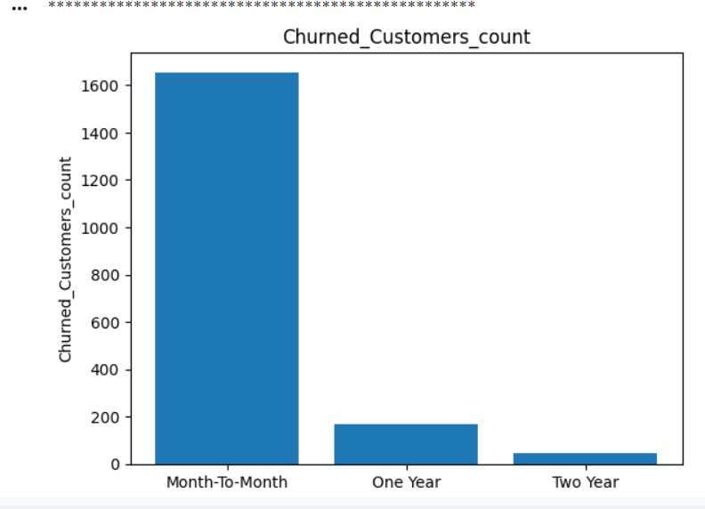
Insight: Determine whether Month-to-Month, One-Year, or Two-Year contracts contribute most to customer attrition.

3. Does customer tenure influence churn behavior?
Visualizations:
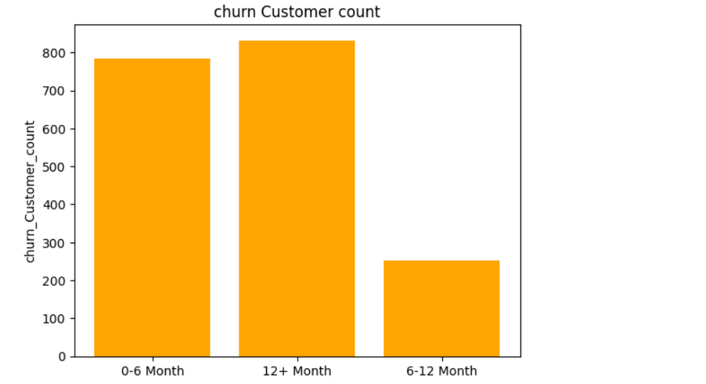
Insight: Analyze whether new customers are more likely to churn compared to long-term customers.

4. How do monthly charges and total charges impact churn?
Visualizations:
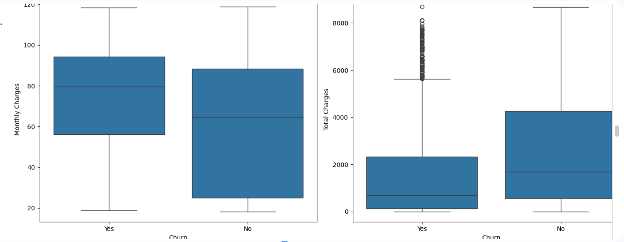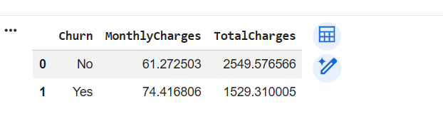
Insight: Understand whether customers paying higher monthly bills are more likely to leave.

5. Which payment methods are associated with the highest churn?
Visualizations:
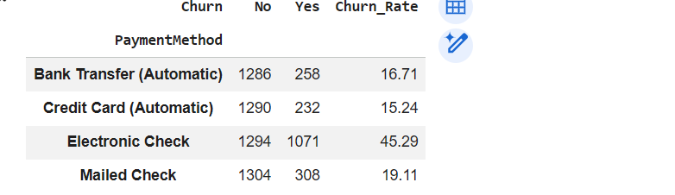

Insight: Identify payment methods that may negatively affect customer retention.

6. Does internet service type influence customer churn?
Visualizations:
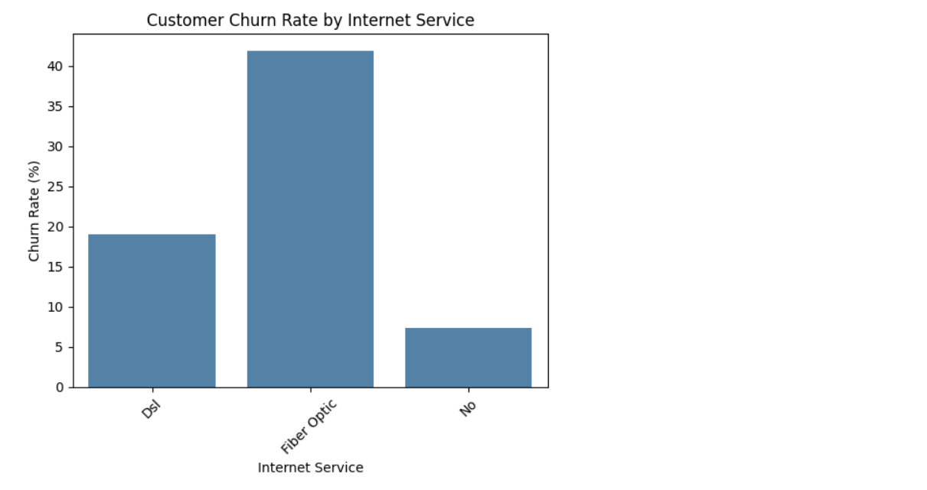
Insight: Compare churn rates among Fiber Optic, DSL, and customers without internet service.

7. Which value-added services reduce customer churn?
Visualizations:

Insight: Evaluate the impact of Online Security, Online Backup, Device Protection, Tech Support, Streaming TV, and Streaming Movies on customer retention.

8. Are senior citizens more likely to churn than other customers?
Visualizations:
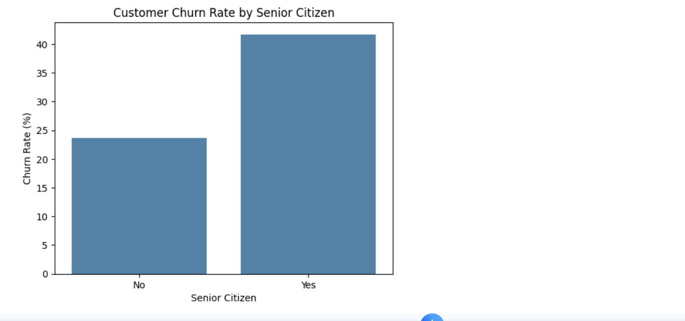
Insight: Determine whether age group influences customer retention.

9. Which customer risk category contributes the highest number of churned customers?
Visulizations:
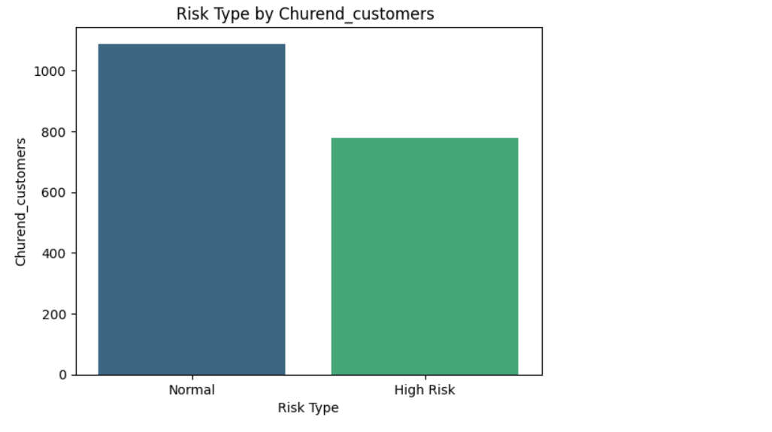
Insight: Identify high-risk customer groups for proactive retention campaigns.

10. What are the characteristics of customers who remain loyal?
Visualizations
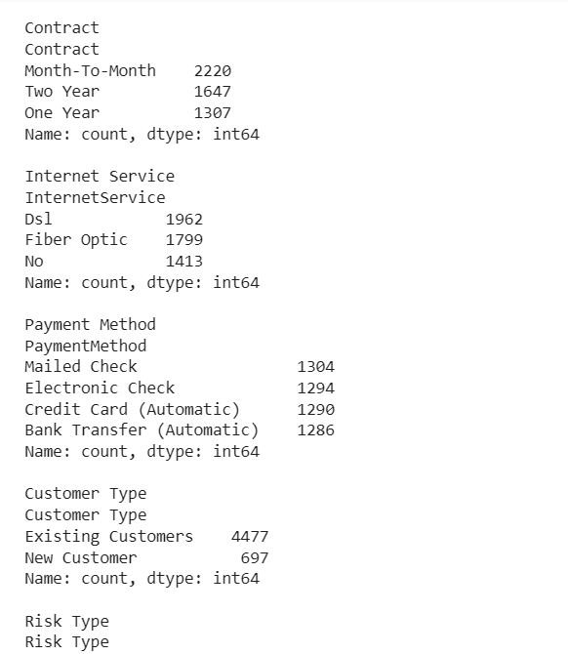
Insight: Discover common attributes shared by retained customers to replicate successful retention strategies.

💡 Business Recommendations

1. Encourage customers to switch from Month-to-Month contracts to long-term contracts.
Expected Outcome: Improve customer retention by increasing customer commitment and reducing churn.

2. Introduce targeted retention offers for new customers during their initial months.
Expected Outcome: Reduce early-stage churn by improving onboarding and customer engagement.

3. Bundle value-added services such as Online Security and Tech Support with internet plans.
Expected Outcome: Increase customer satisfaction and reduce churn through enhanced service value.

4. Review pricing strategies for customers with high monthly charges.
Expected Outcome: Improve customer retention by balancing pricing with perceived service value.

5. Launch personalized retention campaigns for high-risk customer segments.
Expected Outcome: Proactively engage customers most likely to churn and reduce customer attrition.

6. Optimize payment options and promote convenient digital payment methods.
Expected Outcome: Enhance customer experience and minimize churn caused by billing or payment-related issues.

